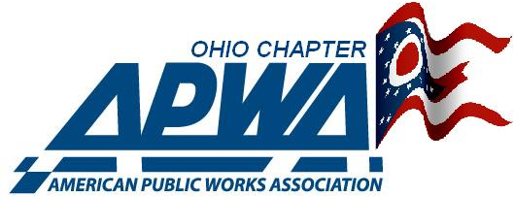
2025 Ohio Public Works Expo June 4th & 5th Hilton Garden Inn Perrysburg, Ohio

ATTENDEE REGISTRATION FORM
Organization Name:
Contact Person: Phone number:
Organization Address:

Office Phone Number: Fax:
Email address:
Registration per attendee is $55 ($45 for 11 or more attendees from same agency)
Number of attendees: EXPO Only (June 5th) X $55($45) =
*Snow & Ice Course (June 4th) (see info sheet) X $175 =
*Leadership Curse (June 4th) (see info sheet) X $175 =
* Those attending June 4th courses includes EXPO pass on June 5th. GRAND TOTAL . .

Purchase Order Number: (Ohio APWA will invoice)
List names of all attendees:
 .
.
.
.
E-MAIL REGISTRATION TO: Kroessne5@aol.com
Credit Card Payment? 

Contacts: Dennis Boyle 419-250-0519 Kim Roessner 419-308-4298
Mail payment to: Ohio APWA 2025 OPWE 1189 W. Central Ave. Toledo, Ohio 43610

